Sikidegek program funkciónális tesztelése

|  |  |  |  |  |
| --- | --- | --- | --- | --- |
| **Alakzat** | **Input** | **Elvárt eredmény** | **Kapott eredmény** | **OK/NOK** |
| **Négyzet** | 1. a = 1 | K = 4 T = 1 | K = 4 T = 1 | **OK** |
| 2. a = 4 | K = 16 T = 16 | K = 16 T = 16 |
| **Háromszög** | 1. a = 1 b = 2 c = 3 | K = 6 T = 0 | K = 6 T = 0 | **OK** |
| 2. a = 10 b = 22 c = 14 | K = 46 T = 51,87 | K = 46 T = 51,87 |
| 3. a = 1 b = 2 c = 4 | Nincs ilyen háromszög | Nincs ilyen háromszög |
| **Téglalap** | 1. a = 1 b = 2 | K = 6 T = 2 | K = 6 T = 2 | **OK** |
| 2. a = 10 b = 20 | K = 60 T = 200 | K = 60 T = 200 |
| **Paralelo-gramma** | 1. a = 5 b = 8 m = 3 | K = 26 T = 24 | K = 26 T = 24 | **OK** |
| 2. a = 10 b = 20 m = 8 | K = 60 T = 160 | K = 60 T = 160 |
| **Rombusz** | 1. a = 4 e = 7 | K = 16 T = 13,6 | K = 16 T = 13,6 | **OK** |
| 2. a = 4 e = 8 | Ilyen alakzat nem létezik | Ilyen alakzat nem létezik |
| **Kör** | 1. r = 1 | K = 6,28 T = 3,14 | K = 6,28 T = 3,14 | **OK** |
| 2. r = 5 | K = 31, 42 T = 78,54 | K = 31,42 T = 78,54 |
| **Trapéz** | 1. a = 1 b = 2 c = 3 | K = 7 T = 2,17 | K = 7 T = 2,17 | **NOK** |
| 2. a = 1 b = 2 c = 6 | Ilyen alakzat nincs | K = 11 T = NaN |
| **Deltoid** | 1. a = 4 b = 8 e = 4 f = 12 | K = 24 T = 24 | K = 24 T = 24 | **OK** |
| 2. a = 4 b= 8 e = 4 f = 13 | Hibás bemeneti adatok | Hibás bemeneti adatok |
| **Kör** | 1. r = 5 | F = 31,42 V = 523,60 | F = 314,16 V = 523,60 | **NOK** |
| **Gúla** | 1. a = 5 m = 5 | F = 80,90 V = 41,97 | F = 80,90 V = 41,97 | **OK** |
|  | 2. a = 5 m = 30 | F = 326,04 V = 250 | F = 326,04 V = 250 |  |
| **Henger** | 1. r = 5 m = 5 | F = 314,16  V = 392,70 | F = 157,08  V = 392,70 | **NOK** |

Trapéz hiba képe:

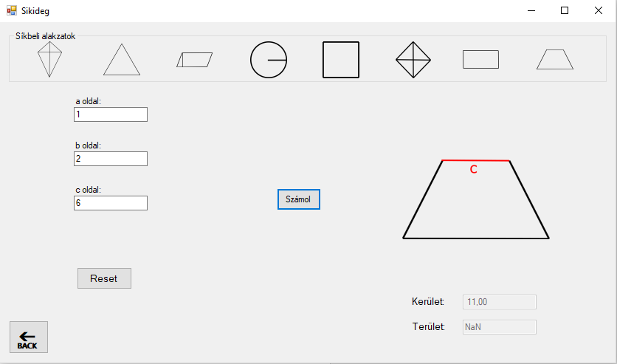

Kör hiba képe:

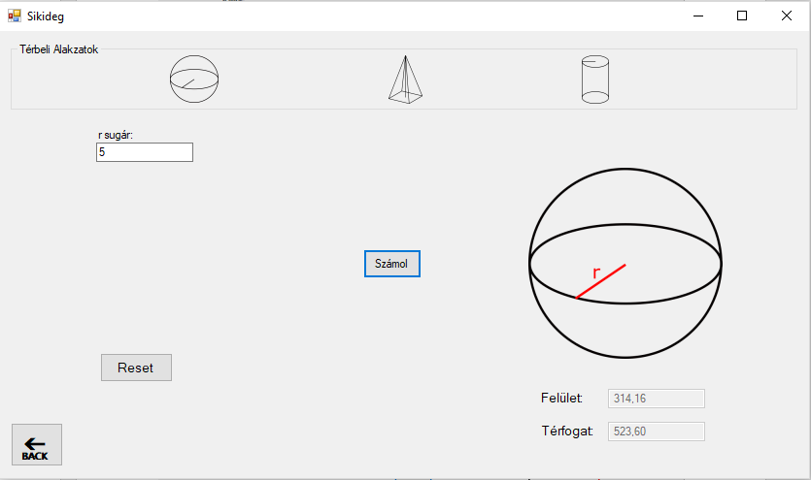

Henger hiba képe:

